**Assignment 01**

1. Create a blank file named "myfile"

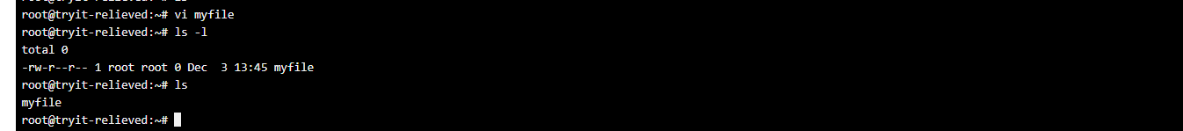

1. Open "myfile" in vi editor

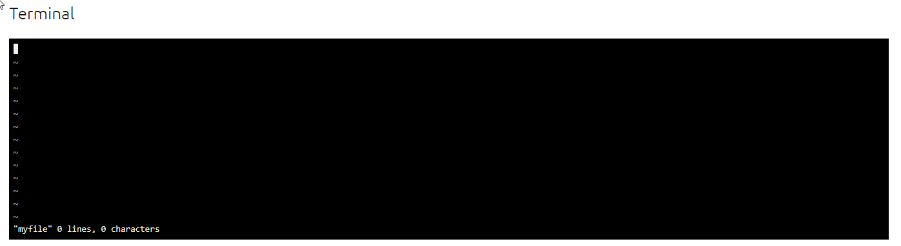

1. Write your name, address, email id, phone number and blood group in 5 different lines

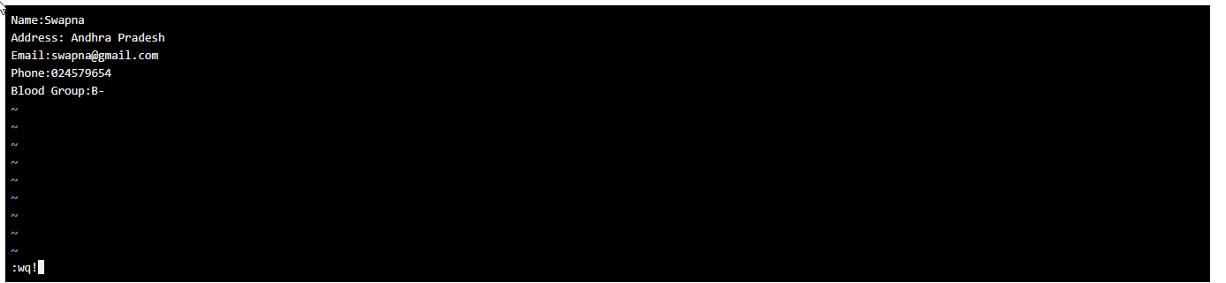

1. Build one single expression to see the line with your name and blood group in myfile

